**Arduino IDE (Integrated Development Environment)**

**Overview and Functionality:** Arduino IDE is a software platform developed to simplify programming and development for Arduino microcontroller boards. It provides a user-friendly interface that allows users to write, compile, and upload code to Arduino boards. The IDE is designed to be accessible to both beginners and experienced programmers, making it a popular choice for creating a wide range of electronic projects.

**Key Features:**

* Code Editor: Arduino IDE offers a code editor with features like syntax highlighting, auto-indentation, and code completion, which help streamline the coding process.
* Code Verification: It includes a feature that checks for syntax errors and highlights them in the code.
* Compilation: Users can compile their code, which transforms their human-readable code into machine-readable binary code that the microcontroller can understand.
* Upload: Once the code is compiled, it can be uploaded or "flashed" onto an Arduino board using a USB connection.
* Library Management: Arduino IDE comes with a vast library of pre-written functions and code snippets (libraries) that simplify working with various sensors, modules, and components.
* Serial Monitor: The IDE includes a serial monitor that enables communication between the computer and the Arduino board, allowing users to send and receive data.
* Board Manager: The Board Manager feature lets users install and manage different board packages, expanding the range of supported hardware.
* Integrated Examples: The IDE offers numerous example sketches that showcase various functionalities of Arduino boards and components.
* Platform Independence: Arduino IDE is available for Windows, macOS, and Linux, ensuring accessibility on multiple operating systems.

**Development Workflow:**

* Writing Code: Users write their code in the Arduino IDE's code editor, using the simplified C/C++ variant supported by the IDE.
* Compiling: After writing the code, users compile it to generate a binary file compatible with the chosen Arduino board.
* Uploading: The compiled binary is uploaded to the Arduino board via a USB connection, making the microcontroller execute the programmed instructions.
* Interacting: Users can interact with the running program using the serial monitor to monitor sensor data, send commands, or debug issues.

**Types of Arduino Boards**

Arduino offers a diverse range of boards, each tailored to specific applications and requirements. Here are some common types:

**Arduino Uno:**

* The most popular and widely used board.
* The best board to get started with electronics and coding.
* Based on the ATmega328 microcontroller.
* Features a balanced mix of I/O pins, memory, and processing power.

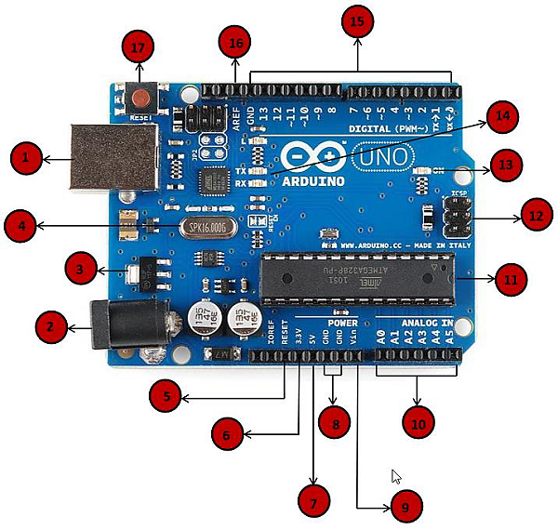

|  |  |
| --- | --- |
| Power USB | **Power USB:** Arduino board can be powered by using the USB cable from your computer. All you need to do is connect the USB cable to the USB connection. |
| Barrel Jack | **Power (Barrel Jack):** Arduino boards can be powered directly from the AC mains power supply by connecting it to the Barrel Jack. |
| Voltage Regulator | **Voltage Regulator:** The function of the voltage regulator is to control the voltage given to the Arduino board and stabilize the DC voltages used by the processor and other elements. |
| Crystal Oscillator | **Crystal Oscillator:** The crystal oscillator helps Arduino in dealing with time issues. How does Arduino calculate time? The answer is, by using the crystal oscillator. The number printed on top of the Arduino crystal is 16.000H9H. It tells us that the frequency is 16,000,000 Hertz or 16 MHz. |
| Arduino Reset | **Arduino Reset:** You can reset your Arduino board, i.e., start your program from the beginning. You can reset the UNO board in two ways. First, by using the reset button (17) on the board. Second, you can connect an external reset button to the Arduino pin labelled RESET (5). |
| Pins | **Pins (3.3, 5, GND, Vin)**   * 3.3V (6) − Supply 3.3 output volt * 5V (7) − Supply 5 output volt * Most of the components used with Arduino board works fine with 3.3 volt and 5 volts. * GND (8) (Ground) − There are several GND pins on the Arduino, any of which can be used to ground your circuit. * Vin (9) − This pin also can be used to power the Arduino board from an external power source, like AC mains power supply. |
| Analog pins | **Analog pins:** The Arduino UNO board has six analog input pins A0 through A5. These pins can read the signal from an analog sensor like the humidity sensor or temperature sensor and convert it into a digital value that can be read by the microprocessor. |
| Main microcontroller | **Main microcontroller:** Each Arduino board has its own microcontroller. You can assume it as the brain of your board. The main IC (integrated circuit) on the Arduino is slightly different from board to board. The microcontrollers are usually of the ATMEL Company. You must know what IC your board has before loading up a new program from the Arduino IDE. This information is available on the top of the IC. For more details about the IC construction and functions, you can refer to the data sheet. |
| ICSP pin | **ICSP pin:** Mostly, ICSP (In-Circuit Serial Programming) is an AVR (AVR is the architecture (developed by Atmel) of the microcontroller chip used in all official 8-bit boards), a tiny programming header for the Arduino consisting of MOSI, MISO, SCK, RESET, VCC, and GND. It is often referred to as an SPI (Serial Peripheral Interface), which could be considered as an "expansion" of the output. Actually, you are slaving the output device to the master of the SPI bus. |
| Power LED indicator | **Power LED indicator:** This LED should light up when you plug your Arduino into a power source to indicate that your board is powered up correctly. If this light does not turn on, then there is something wrong with the connection. |
| TX and RX LEDs | **TX and RX LEDs:** On your board, you will find two labels: TX (transmit) and RX (receive). They appear in two places on the Arduino UNO board. First, at the digital pins 0 and 1, to indicate the pins responsible for serial communication. Second, the TX and RX led (13). The TX led flashes with different speed while sending the serial data. The speed of flashing depends on the baud rate used by the board. RX flashes during the receiving process. |
| Digital I/O | **Digital I/O:** The Arduino UNO board has 14 digital I/O pins (of which 6 provide PWM (Pulse Width Modulation) output. These pins can be configured to work as input digital pins to read logic values (0 or 1) or as digital output pins to drive different modules like LEDs, relays, etc. The pins labeled “~” can be used to generate PWM. |
| AREF | **AREF:** AREF stands for Analog Reference. It is sometimes, used to set an external reference voltage (between 0 and 5 Volts) as the upper limit for the analog input pins. |

**Arduino Mega:**

* Larger and more powerful than Uno.
* Utilizes the ATmega2560 microcontroller.
* Ideal for projects requiring extensive I/O pins and memory.

**Arduino Nano:**

* Compact and suitable for projects with limited space.
* Similar to Uno but smaller.
* Based on the ATmega328 microcontroller.

**Arduino Due:**

* Equipped with an advanced ARM Cortex-M3 SAM3X8E microcontroller.
* Offers increased processing power and I/O capabilities.

**Arduino Leonardo:**

* Utilizes the ATmega32U4 microcontroller.
* Offers built-in USB communication capabilities, allowing it to emulate a keyboard or mouse.

**Arduino MKR Series:**

* Designed for IoT applications with integrated Wi-Fi, GSM, or LoRa communication.
* Ideal for remote sensing and data transmission projects.

**Arduino ESP8266 and ESP32:**

* While not traditional Arduino boards, these are microcontrollers with integrated Wi-Fi and Bluetooth capabilities.
* Well-suited for IoT projects requiring wireless connectivity.

**Arduino LilyPad:**

* Created for wearable and e-textile projects.
* Circular and sewable, designed for integrating electronics into fabrics.

Though each Arduino board type has specific features, capabilities, and use cases, most Arduinos have majority of the components in common. The choice of board depends on factors such as project requirements, available features, budget, and familiarity with the hardware. Arduino's wide range of boards ensures that users can select the most suitable one for their specific applications and projects.

Here's a comparative summary of some popular Arduino boards, highlighting their key features, specifications, and typical use cases:

|  |  |  |  |  |  |  |  |
| --- | --- | --- | --- | --- | --- | --- | --- |
| **Arduino boards** | **Microcontroller** | **Clock Speed** | **Digital I/O**  **Pins** | **Analog Input Pins** | **Flash Memory** | **RAM** | **Use Cases** |
| **Arduino Uno** | ATmega328P | 16 MHz | 14 | 6 | 32 KB | 2 KB | General-purpose projects, learning programming, basic electronics. |
| **Arduino Mega** | ATmega2560 | 16 MHz | 54 | 16 | 256 KB | 8 KB | Projects requiring extensive I/O, robotics, complex applications. |
| **Arduino Nano** | ATmega328P | 16 MHz | 14 | 8 | 32 KB | 2 KB | Compact projects, wearables, small-scale applications. |
| **Arduino Due** | SAM3X8E (ARM Cortex-M3) | 84 MHz | 54 | 12 | 512 KB | 96 KB | High-performance projects, data-intensive applications. |
| **Arduino Leonardo** | ATmega32U4 | 16 MHz | 20 | 12 | 32 KB | 2.5 KB | Projects requiring USB communication, keyboard/mouse emulation. |
| **Arduino MKR Series** | SAMD21 (ARM Cortex-M0+) | 32.768 kHz to 48 MHz | Varies by model | Varies by model | 256 KB | 32 KB | IoT projects, wireless communication, battery-powered devices. |
| **Arduino ESP8266/ESP32** | ESP8266/ESP32 | Varies by model | Varies by model | Varies by model | Varies by model | Varies by model | IoT, Wi-Fi/BT-enabled projects, home automation. |
| **Arduino LilyPad** | ATmega328P | 8 MHz | 14 | 6 | 32 KB | 2 KB | Wearable electronics, e-textiles, fabric-based projects. |